Philips Hue Bridge 2.0

The hue bridge is derived from a Linux based router, where the linux distribution provided by ODM.

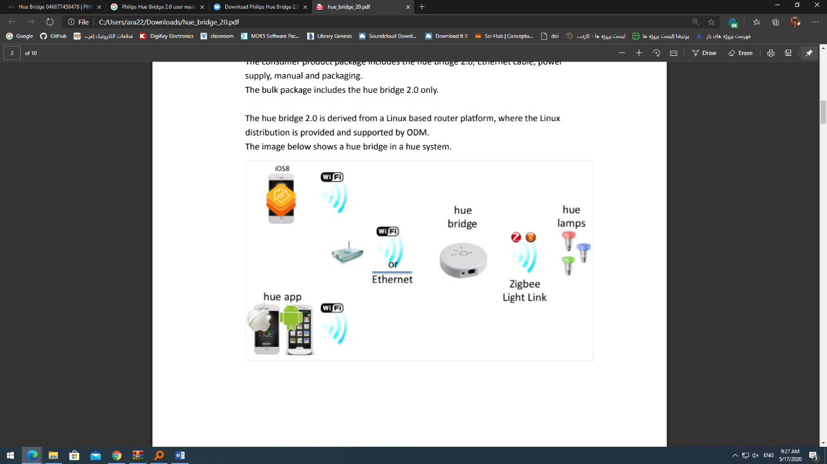

For more information:

User manual:

<https://www.manualslib.com/download/1361361/Philips-Hue-Bridge-2-0.html>

supplier:

<https://www2.meethue.com/en-us/p/hue-bridge/046677458478>

